**Figures for Problem 3**

Binary_SVM_C=100

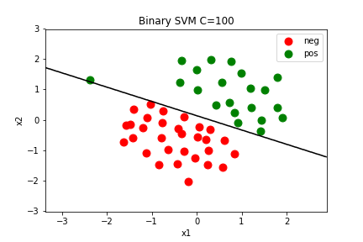

Gaussian_Dataset2_DecisionBoundary

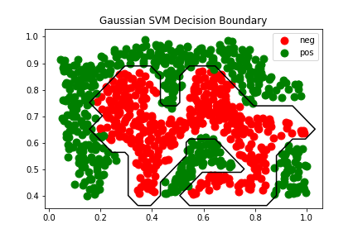

Gaussian_Dataset3_DecisionBoundary

